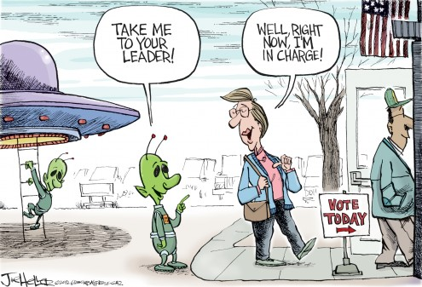
Name________________________________________Date______________________________ Period_________
Executive Branch Webquest
http://www.whitehouse.gov/our-government/executive-branch
1.The Power of the Executive Branch is vested in who and he/she acts as what?

2. The President is responsible for what?

3.The Vice President is part of the Executive Branch. What is his/her primary responsibility?

4.The Presidential Cabinet and independent federal agencies are also part of the Executive Branch. What are
they responsible for?

5. What article in the Constitution describes the powers of the Executive Branch?

6. What are the three qualifications for president?

7. What are the names of our current President and Vice President?

8. What are the names of the 15 executive departments that make up the Presidential Cabinet?

http://www.flocabulary.com/3-branches-of-government/
9. What are the checks and balances in the lawmaking process for the legislative, executive, and judicial branch?

10. How many votes does Congress need to override a Presidential veto?

http://www.factmonster.com/ipka/A0774837.html
11. What is the election process of the President?

12. Analyze the political cartoon at top of page:

http://www.youtube.com/watch?v=rIK1LAjVKpk
13. When people cast their ballot to vote for President, what are they actually voting for?

14. What is the electoral college?

15. What is the formula that determines how many electoral votes a state will get?

http://www.270towin.com/
16. How many electoral votes does it take to win the presidency?

17. What are the top 5 states with the most electoral college votes?

18. Can a candidate win the presidency without winning any of those 5 states? What does the map look like?

19. What is the easiest way for a candidate to get to the necessary electoral votes to win the presidency?

http://www.youtube.com/watch?v=OUS9mM8Xbbw
20. How many total votes are in the electoral college?

