Name: Date: Period:

Ancient Civilizations
Nile River Valley (NRV)/Ancient Egypt

Essential Questions: Why did people first settle along the Nile River? What role did religion have on the culture of the people of Ancient Egypt? What was the impact of government on the people living in Ancient Egypt? How did technology improve the lives of the people of Ancient Egypt?

Part 1: Basic Comprehension

Directions: Complete the research questions by using the online website and webquest activities below.

Mummies, Pyramids, Pharaohs, Oh My!
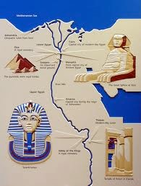

Section 1: Mummification
Goal: To comprehend and analyze who, what, where, when, why, and how mummification worked.

1) Use the Website below to complete the “Mummy Madness” activity. The pictures in your packet match the pictures on the Webpage:

http://www.ancientegypt.co.uk/mummies/story/main.html

Part 1: The Embalming Process
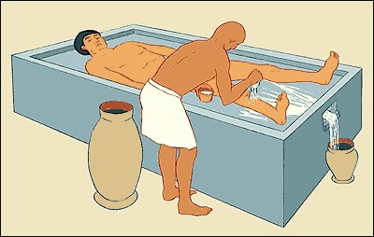
- What is the “ibu?”

- Why are wine and water used?

(Click “Next” on the website)

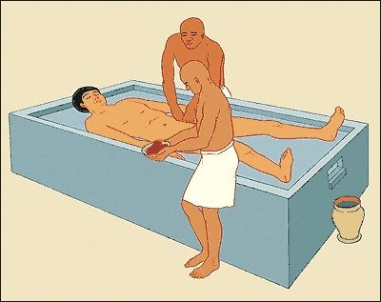

- How and why are the internal organs removed from the body?

- What is natron?

- Why is the heart left inside the body?

- How is the brain removed?

(Click “Next” on the website)

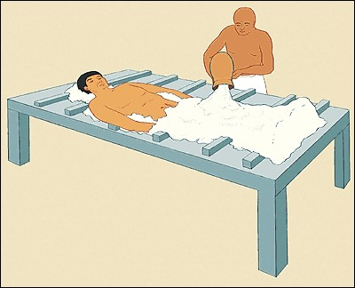
7. What does this picture show?

(Click “Next” on the website)
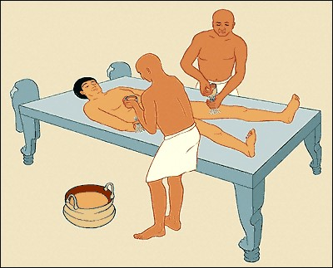
- How long is the body dried out for?

- Why is the body covered in oils?

(Click “Next” on the website)
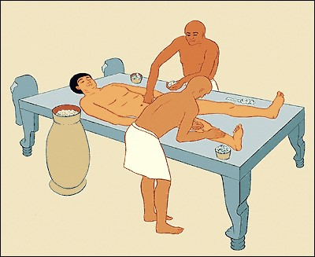
- What are the internal organs wrapped in?

(Click “Next” on the website)
- What were the internal organs placed in previously?

(Click “Next” on the website)

Part 2: The Wrapping Process

(Click on “Wrapping”)
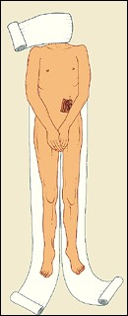
- What was wrapped first?

- Why were the fingers and toes wrapped individually?

(Click “Next” on the website)
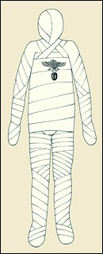
- What is wrapped next?

- Why are amulets placed on the body?

(Click “Next” on the website)
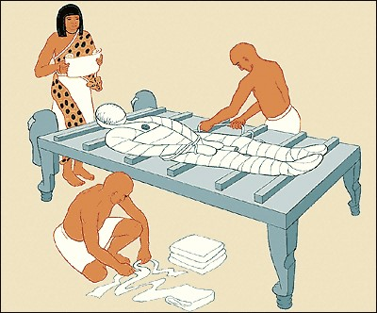
16. Why does a priest read spells while the mummy is wrapped?

(Click “Next” on the website)
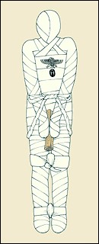
17. What is placed between the hands of the mummy?

(Click “Next” on the website)
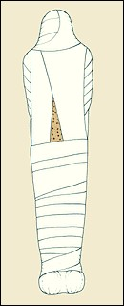
18. Why is resin put on the linens?

(Click “Next” on the website)
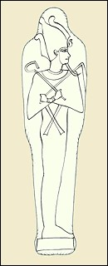
19. Why is a picture of Osiris painted on the mummy?

(Click “Next” on the website)
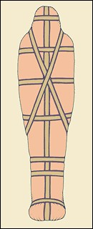
20. Why is the mummy placed in more than 1 coffin?

(Click “Next” on the website)
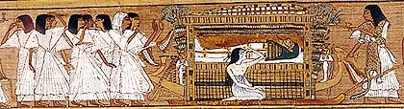
21. What does this picture show?

(Click “Next” on the website)
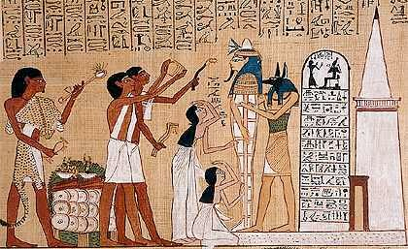
- What is the “Opening of the Mouth” ceremony?

- What other items are buried with the mummy?

- How is the body judged in the afterlife?

Section 2: Pyramids of Ancient Egypt
Goal: To comprehend and analyze who/what/where/when/why/how the pyramids/sphinx where built.

1) Use the Websites to complete the “Egyptian Pyramid” activity:
http://www.ancientegypt.co.uk/pyramids/home.html

http://www.history.com/topics/ancient-history/the-egyptian-pyramids

http://www.primaryhomeworkhelp.co.uk/egypt/pyramids.htm

http://www.historyforkids.net/egyptian-pyramids.html

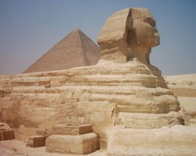

- Who were the pyramids built for?

- Who “built” the pyramids?

- What was placed inside the pyramids (besides the pharaoh)?

- Where were most pyramids built in ancient Egypt?

When did the ancient Egyptians build most pyramids?

- Why were the pyramids built (several reasons)?

- How was a pyramid created?

- How long did it take to build a pyramid?

2) Pick one of the following architecture structures to research:

Great Pyramid
http://www.nationalgeographic.com/pyramids/khufu.html
http://www.ancientegyptonline.co.uk/great-pyramid.html
http://www.history.com/topics/ancient-history/ancient-egypt/videos/deconstructing-history-the-great-pyramid
https://www.youtube.com/watch?v=ZWqrwutNMEQ

Sphinx
http://www.guardians.net/egypt/sphinx/
http://www.ancientegypt.co.uk/pyramids/about/sphinx.html
http://www.ancient-code.com/20-facts-about-the-great-sphinx-of-egypt/
https://www.youtube.com/watch?v=y8x7zKy2U5E https://www.youtube.com/watch?v=afIWCEa_E7Q

Red Pyramid
http://www.nationalgeographic.com/pyramids/north.html http://www.touregypt.net/featurestories/red.htm
http://www.ancientegyptonline.co.uk/red-pyramid-dashur.html https://www.youtube.com/watch?v=o3kxrRldj1s

Djoser’s Pyramid
http://www.nationalgeographic.com/pyramids/djoser.html
http://www.ancientegyptonline.co.uk/djosersteppyramid.html
https://discoveringegypt.com/pyramids-temples-of-egypt/step-pyramid-at-saqqara/
https://www.youtube.com/watch?v=U7ZVjtRGBt8 https://www.youtube.com/watch?v=DWtLMm0Jgbg

- Who was the structure build for?

- Why was it built?

- How was it built and how long did it take to build?

- What material was it made out of?

- Where was/is the it located?

- Describe the size (height, width, length, number of blocks, etc.):

- 10 Interesting facts about the structure:

Section 3: Pharaohs of Ancient Egypt
Goal: To comprehend and analyze the roles & responsibilities of the ancient Egyptian pharaohs.

1) Use the Websites to complete the “Egyptian Pharaohs” activity:

http://www.ancientegypt.co.uk/pharaoh/home.html
http://www.touregypt.net/featurestories/pharaohs.htm
http://www.mummies2pyramids.info/pharaohs-kings/role-of-pharaoh.htm
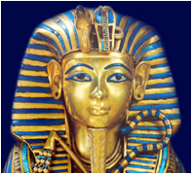

- Who were the pharaohs?

- What powers did the pharaohs have in government?

- What role did the pharaohs play in religion?

- How was the pharaoh “god-like?”

2) Pick one of the following pharaohs to research in detail:

Hatshepsut:
http://www.history.com/topics/ancient-history/hatshepsut
http://www.kingtutone.com/queens/hatshepsut/ http://www.pbs.org/empires/egypt/newkingdom/hatshepsut.html
http://study.com/academy/lesson/queen-hatshepsut-facts-accomplishments-death.html
https://www.youtube.com/watch?v=s9jmZiy_T-c
https://www.youtube.com/watch?v=8bYRy_wZEJI

Ramses II:
http://www.pbs.org/empires/egypt/newkingdom/ramesses.html http://www.ancient-egypt-online.com/ramses-II.html
http://www.touregypt.net/featurestories/ramesses2intro.htm https://www.youtube.com/watch?v=axttkV4Gs8c
http://study.com/academy/lesson/queen-hatshepsut-ramses-the-great-of-egypt.html

Tutankhamen:
http://www.kingtutone.com/tutankhamun/
http://www.history.com/news/history-lists/6-secrets-of-king-tut
http://www.biography.com/people/king-tut-9512446#death-and-burial http://www.history.com/topics/ancient-history/tutankhamen https://www.youtube.com/watch?v=dmkDPaHSBzg
https://www.youtube.com/watch?v=3pKOcOITUHo

Cleopatra:
http://www.ancientegyptonline.co.uk/CleopatraVII.html http://www.touregypt.net/cleopatr.htm
http://www.history.com/topics/ancient-­‐‑history/cleopatra
http://www.history.com/news/10-­‐‑little-­‐‑known-­‐‑facts-­‐‑about-­‐‑cleopatra http://www.history.com/topics/ancient-­‐‑history/cleopatra

1.When did the pharaoh rule?

2. What are some of his/her accomplishments?

- What are some of his/her negatives as a ruler?

- Interesting facts about the pharaoh:

- Summary of pharaoh’s rule:

